 Author’s Paper Specifications 

Each submission must be identified as one of the following:
Completed paper
Research-in-progress: The authors need to have an interesting problem that is clearly motivated and the submission should stand on its own. The authors are expected to have some preliminary results to report on by the time of their presentation.
Practice-oriented paper: A Practice-oriented paper may be submitted as a research paper or as a Microsoft PowerPoint file. Note: Because ICIQ is not a commercial conference, we request that presentations have NO LOGOS.
Poster Session: Research-in-progress can be submitted as a research-in-progress paper for inclusion in the proceedings or as a poster session (abstract only in the proceedings or overview power point slide). Submissions for poster session may be in the form of a short paper or power point slides. Authors of accepted poster session presentations will be given formats at the time of acceptance. Post Submissions are those still in the early stage of research/practice, but you believe warrant presenting in the ICIQ conference for feedback and early dissemination.
IMPORTANT for Double-Blind review: PLEASE DO NOT include name and affiliation on the cover sheet of the file you upload to Microsoft Conference Management Tool (CMT) for acceptance/rejection review. This will ensure that your reviewers will review your submission without bias one way or the other. Because you will not know who your reviewers are as well, it is referred to as "double-blind". Double-blind review is the gold standard for top-tier conference in the Informaiton Technology field. Because we now fast-track high-quality papers to ACM JDIQ, in addition to the Madnick Best Paper Award, it is imperative that you DO NOT include your name and affiliation in the file you upload to CMT.
Please submit your paper using the formatting specified below. We have created an example/template to use along with these specifications.

General Paper Specifications:
Medium: electronic file in Microsoft® Word
Paper Size: Letter (8.5 x 11 in.) (215.90 mm x 279.18 mm)
Maximum number of Pages: 15, including references and appendices

Page Setup:
Margins: (see ‘Tips’, below) Top: 1”; Bottom: 1”; Left: 1”; Right: 1” (25.38 mm)
Header from edge: Keep U.S. default (0.5”/12.69 mm)
Footer from edge: Keep U.S. default (0.5”/12.69 mm)

Text & Paragraph Formatting:
Font: Times New Roman
Line Spacing: Single (see ‘Tips’, below)
Title: 18 points, bold, small caps***, centered, 3 lines down from top (click the top of the page and press the ‘ENTER’ key on your keyboard 3 times)
Paper Category: 11 points, centered, in parentheses & following the title: identify your paper as
“Research- in-progress,” “Research Paper,” or “Practice-Oriented”; press the ‘ENTER’ key 2 times before typing ‘Author Name’
Topic Category: Select one or more topics from the list in the Call for Papers e.g. “IQ Concepts, Tools, Metrics, Measures, Models, and Methodologies” or else enter “Other” with a description of your choice.
Author Name: 11 points, bold, centered
Affiliation: 11: points, centered
E-mail Address: 10 points, centered, press the ‘ENTER’ key 2 times before typing ‘Abstract’
Abstract: 10 points, centered, indented by .75”(11.42 mm) both left and right; press the ‘ENTER’ key
2 times before typing ‘Key Words’
Key Words (optional): 10 points, left-justified; press the ‘ENTER’ key 3 times before ‘Heading 1’
Heading 1: 16 points, bold, small caps (see ‘Tips’, below); leave 3 blank lines above Heading 1
Heading 2: 14 points, bold, italic; leave 1 blank lines above Heading 2
Heading 3: 11 points, bold, leave 1 blank line above Heading 3
Body Text: 11 points, justified
References: 10 points

Sections
Your paper should be organized as follows: Introduction, Background, Rationale & purpose, Methods, Results, Discussion, Limitations, and Conclusion, Bibliography and Appendices.

Page Numbers:
NONE

Figures and Tables:

Caption: Title and figure number beneath figure/table, justified left

References
In the body of the paper:
Place quotes in square brackets with number only, e.g., [2]
At the end of the paper:
Number all references in alphabetical order by author, for example:
Journal article:
[1] DeLone, W. H., McLean, E. R. “Information Systems Success: The Quest for the Dependent Variable.” Information Systems Research, 3 (1). 1992. pp.60-95
Book:
[2] Bonini, C. P. Simulation of Information and Decision Systems in the Firm. Prentice-Hall. Englewood Cliffs, NJ., 1963. p. 137

Papers that do not conform to the guidelines may not be included in the conference proceedings.

***Tips

MARGINS
To Create 1” Margins in Microsoft® Word:

1. In the menu bar, click “File”:



2. In the “File” drop-down menu, click “Page Setup”:

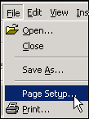

3. Click the cursor in the box across from “Top:” and type ‘1’; Repeat for ‘Bottom, ‘Left’, ‘Right’

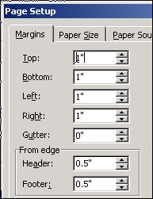

SINGLE SPACING
1. From the menu bar, click “Format” 2. From the drop-down menu, click “Paragraph”

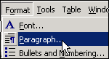

3. In the ‘Paragraph’ dialog box, under “Line spacing:” click “Single.” Click the ‘OK’ button.

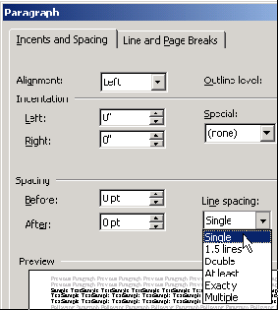

SMALL CAPS

1. From the menu bar, click “Format” 2. From the drop-down menu, click “Font”

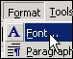

3. In the ‘Font’ dialog box, click “Small caps”. Click the ‘OK’ button.

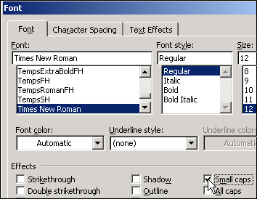

For your convenience we have created an example that can also serve as your template, but you are not required to use it. It can be downloaded from http://www.iqconference.org/ICIQ/Author_Guidelines.htm. If you have questions regarding the paper format, or need assistance, please contact one of the ICIQ program Chairs.

